Font Style: Times New Roman
Main Heading (e.g Declaration, Content Relevance etc ) : 16 Font Size, Bold
Sub Heading : 14 Font Size, Bold
Content: 12 Font Size
Page Numbers for Front Page, Declaration Statement, Acknowledgment and Table of Content should be in Romans e.g (i,ii,iii,iv)

Page Numbers for Content Relevance, Methodology and Implementation should be in Numbers e.g(1,2,3,4)

- Front Page
- Declaration Statement
- Acknowledgment
- Table of Content
- Content Relevance (Write Introduction of our project. What your project is all about. Include Module wise description as well)
- Methodology(flow chart and Gantt chart)
- Implementation (Put screenshots of all the windows with their explanation)

NOTE: Convert your .doc or .docx file to pdf file before taking the print out otherwise the alignment of your will be changed while taking the print out.

SPIRAL BIND YOUR REPORT FILE

WRITE YOUR PROJECT NAME HERE

Mini Project submitted in partial fulfilment of the requirements for the Degree of

BACHELORS OF TECHNOLOGY
in
COMPUTER SCIENCE AND ENGINEERING
By
D.Sai Ram, G. Sanjay Rishi, T. Jagadeesh Kumar.
REGISTRATION NUMBER HERE
Under the Guidance of
Ms. RANJIT KAUR
ASSISSTANT PROFESSOR

School of Computer Science and Engineering
Lovely Professional University
Phagwara, Punjab (India)
NOV 2016
DECLARATION STATEMENT

We hereby declare that the work reported in the Mini Project entitled " WRITE YOUR PROJECT NAME HERE” in partial fulfillment of the requirement for the award of Degree for Bachelors of Technology in Computer Science and Engineering at Lovely Professional University, Phagwara, Punjab is an authentic work carried out under the guidance of Ms. Ranjit Kaur.

Place : Lovely Professional University Name of students
D.Sai ram
G.Sanjay rishi
T.Jagadeesh
Date : 02-11-2016 Reg No.
11502781.
11503767.
11502789.

ACKNOWLEDGEMENT
In performing our assignment, we had to take the help and guideline of some
respected persons, who deserve our greatest gratitude. The completion of this
assignment gives us much Pleasure. We would like to show our gratitude
Ms. Ranjeet Kaur, LPU for giving us a good guideline for assignment
throughout numerous consultations. We would also like to expand our deepest
gratitude to all those who have directly and indirectly guided us in writing this
assignment.
In addition, a thank you to Professor MS.Ranjeet Kaur, who introduced us to
the Methodology of work, and whose passion for the “underlying structures”
had lasting effect. We also thank the University of LPU for consent to include
copyrighted pictures as a part of our paper.

Place : Lovely Professional University Name of students : Reg No:
D.Sai Ram 11502781
G.Sanjay Rishi 11503767
T.Jagadeesh 11502789
Date : 02-11-2016

TABLE OF CONTENT

CHAPTER 1: CONTENT RELEVANCE 1
1.1 Main Page 1
1.2 Order Pizza 1
1.3 Cancel order 4
1.2 Track a 1
1.3 Cancel order 4

CHAPTER 2: METHODOLOGY 15
2.1 16
2.2 Sub Heading 2 17
2.3 Sub Heading 3 18

CHAPTER 1
CONTENT RELEVANCE

Main Page
The main page contains of four Buttons. The buttons are order pizza, cancel, track order and vender. Each Buttons as its own defined functions in the code.

Order pizza
The order pizza contains of labels and entries which will ask the personal details such as address, phone number, name and the order. A menu button is present in the button so that we can select the pizzas. It is directly connected with the database and there are two buttons in the same windows. On of the Button will connect the data entered to the database, one of the button will ask quit.

Cancel
This will contain two labels and entries which will ask the order id and phone number to the user. The data is directly connected to the database and a query will alter the table.

Track Order
This will contain two labels and entries which will ask the order id and phone number to the user. The order will be tracked and it will show either it is pending or not.

Vender
This will contain four buttons. The buttons are new pizza order, cancel order, servered order ,pending details

CHAPTER 2
METHODOLOGY
  - GANTT CHART

2.1 Gantt Chart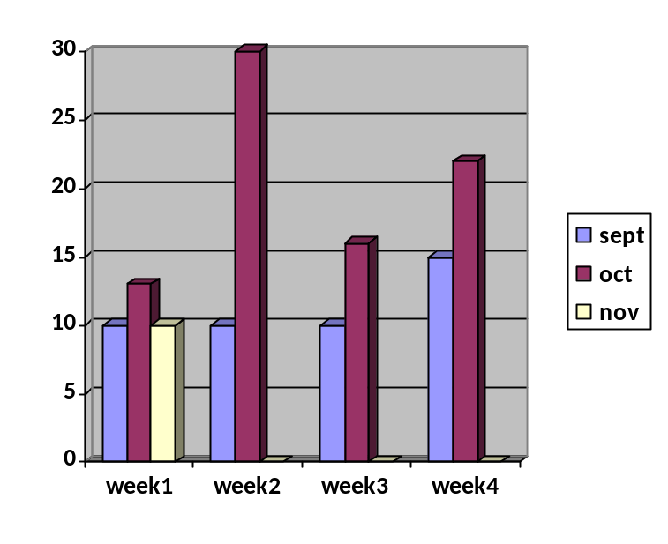

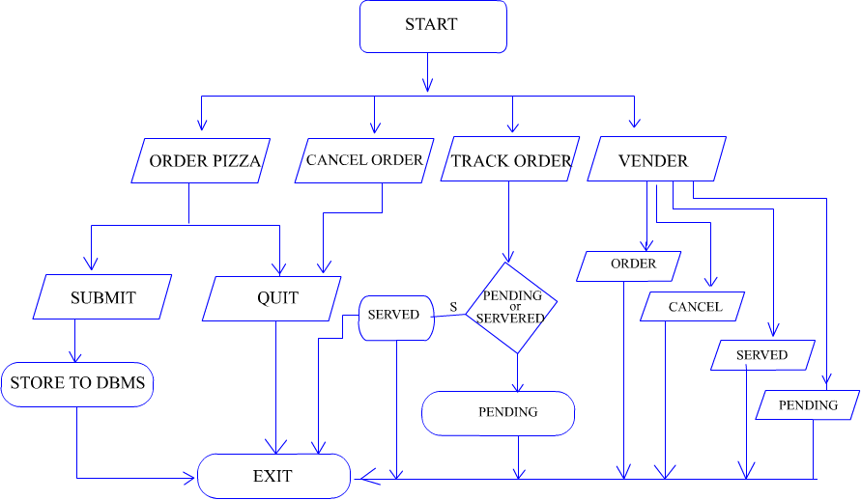
FLOW CHART

EXPLAIN YOUR FLOW CHART HERE STEP BY STEP

CHAPTER 3
IMPLEMENTATION

3.1 Main Page

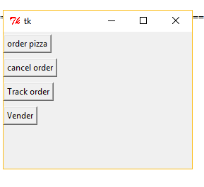
op = Button(top, text ="order pizza", command=order_pizza, activebackground="Red")
co = Button(top,text ="cancel order", activebackground="Red", command=cancel)
to = Button(top,text ="Track order", activebackground="Red", command=track_order)
ve = Button(top,text="Vender", activebackground="Red", command= vender)
op.grid(row=0, sticky=W, pady=4)
co.grid(row=2, sticky=W, pady=4)
to.grid(row=4, sticky=W, pady=4)
ve.grid(row=6, sticky=W, pady=4)
top.mainloop()
  - Order Pizza

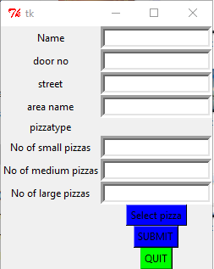

def order_pizza():
order_pizza = Tk()
Name = Label(order_pizza, text="Name").grid(row=0)
entryname = Entry(order_pizza, bd=5)
doorno = Label(order_pizza, text="door no").grid(row=1)
door_no_en=Entry(order_pizza,bd=5)
streetl = Label(order_pizza, text="street").grid(row=2)
street_en=Entry(order_pizza,bd=5)
area = Label(order_pizza, text="area name").grid(row=3)
area_en=Entry(order_pizza,bd=5)
pizzatype = Label(order_pizza,text= "pizzatype")
ph = Label(order_pizza, text="Phone No")
PhE =Entry(order_pizza, bd=5)
L1 = Label(order_pizza, text= "No of small pizzas")
L1E = Entry(order_pizza, bd=5)
L2 = Label(order_pizza, text= "No of medium pizzas")
L2E = Entry(order_pizza, bd=5)
L3 = Label(order_pizza, text= "No of large pizzas")
L3E = Entry(order_pizza, bd=5)
mb= Menubutton(order_pizza, text="Select pizza", relief=RAISED,\
activebackground="Red", bg="Blue")
mb.menu = Menu ( mb, tearoff = 0 )
mb["menu"] = mb.menu
neoVar = IntVar()
dou = IntVar()
Mar = IntVar()
moz = IntVar()
tom = IntVar()
Mus = IntVar()
art = IntVar()
Ham = IntVar()
mb.menu.add_checkbutton ( label="Neapolitan Pizza",\
variable=neoVar )
mb.menu.add_checkbutton ( label="Double Cheese Pizza",\
variable=dou )
mb.menu.add_checkbutton ( label="Margherita Pizza",\
variable=Mar )
mb.menu.add_checkbutton ( label="Mozzarella Pizza",\
variable=moz )
mb.menu.add_checkbutton ( label="Tomato Pizza",\
variable=Mar )
mb.menu.add_checkbutton ( label="Mushrooms Pizza",\
variable=Mar )
mb.menu.add_checkbutton ( label="Artichokes Pizza",\
variable=art )
mb.menu.add_checkbutton ( label="Cooked Ham Pizza",\
variable=Ham )
name=entryname.get()
door_no=door_no_en.get()
street=street_en.get()
area=area_en.get()
Phone_no=PhE.get()
no_of_small=L1E.get()
no_of_medium=L2E.get()
no_of_large=L3E.get()
total=(no_of_small*75)+(no_of_medium*100)+(no_of_large*150)
def dbms(Name, door_no, street, area, Phone_no, no_of_small, no_of_medium, no_of_large, total):
plist=[Name, door_no, street, area, Phone_no, no_of_small, no_of_medium, no_of_large, total]
sqlite_file = 'my_first_db.sqlite'
conn = sqlite3.connect(sqlite_file)
c = conn.cursor()
#c.execute('create sequence sname increment by 1 start with 1 maxvalue 1000 nocycle nocache')
#c.execute('create table pizza_data(name text(10), dr_no int(10), street text(10),area text(10),Ph_no int(10), small int(10), medium int(10), large int(10), total int(10))')
c.execute('select * from pizza_data')
c.execute('insert into pizza_data values(?,?,?,?,?,?,?,?,?)',plist)
#print c.fetchall()
#c.execute('drop table pizza_data')
conn.commit()
conn.close()
submit=Button( order_pizza, text="SUBMIT", relief=RAISED, activebackground="Red",\
bg="Blue", command=dbms(name, door_no, street, area, Phone_no, no_of_small,no_of_medium,no_of_large,total))
quit1 = Button(order_pizza, text='QUIT', relief=RAISED, activebackground="Orange",\
bg="Green",command=quit)
entryname.grid(row=0,column=2)
door_no_en.grid(row=1, column=2)
street_en.grid(row=2, column=2)
area_en.grid(row=3, column=2)
pizzatype.grid(row=4)
L1.grid(row=5)
L1E.grid(row=5, column=2)
L2.grid(row=6)
L2E.grid(row=6, column=2)
L3.grid(row=7)
L3E.grid(row=7, column=2)
mb.grid(row=8, column=2)
submit.grid(row=9, column=2)
quit1.grid(row=10, column=2)
order_pizza.mainloop()
Explain the functioning of 2nd Window here.
  - Cancel order
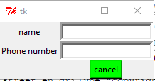

def can(p):
L1=[p]
sqlite_file = 'my_first_db.sqlite'
conn = sqlite3.connect(sqlite_file)
c = conn.cursor()
#c.execute('alter table pizza_data delete column(ph=?)',L1)
conn.commit()
conn.close()
tkMessageBox.showinfo("quit","Thank you")
def cancel():
cancel=Tk()
name=Label(cancel, text="name").grid(row=0)
name_en=Entry(cancel, bd=5).grid(row=0, column=1)
ph=Label(cancel, text="Phone number").grid(row=1)
ph_en=Entry(cancel, bd=5).grid(row=1, column=1)
p=ph_en.get()
submit=Button(cancel, text="cancel",relief=RAISED, activebackground="Orange",\
bg="Green", command=can(p)).grid(row=2,column=1).grid(row=2, column=2)
cancel.mainloop()

Track Order
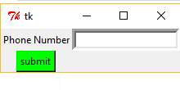
def track():
sqlite_file = 'my_first_db.sqlite'
conn = sqlite3.connect(sqlite_file)
c = conn.cursor()
#l=[p]
c.execute('select * from pizza_data where Ph_no=?',l)
print "soon you will get it"
conn.commit()
conn.close()
def track_order():
track_order=Tk()
ph_l=Label(track_order, text="Phone Number")
ph_en=Entry(track_order, bd=5)
#p1=ph_en.get()
ph_l.grid(row=0)
ph_en.grid(row=0, column=1)
submit=Button(track_order, text='submit', relief=RAISED, activebackground="Orange",\
bg="Green", command= track)
submit.grid(row=1)
track_order.mainloop()

3.4Vender
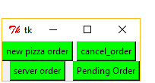
def vender():
vender=Tk()
new_pizza_order = Button(vender, text="new pizza order", relief=RAISED, activebackground="Red",\
bg="Green", command=order_pizza)
cancel_pizza_order=Button(vender, text="cancel_order", relief=RAISED, activebackground="Red",\
bg="Green", command=cancel)
servered_order=Button(vender, text="server order", relief=RAISED, activebackground="Red",\
bg="Green")
pending_order=Button(vender, text="Pending Order", relief=RAISED, activebackground="Red",\
bg="Green")
new_pizza_order.grid(row=0)
cancel_pizza_order.grid(row=0,column=3)
servered_order.grid(row=2)
pending_order.grid(row=2, column=3)
vender.mainloop()

